Abstract Template of Eleventh International Conference on Computational Fluid Dynamics at Maui, Hawaii 2020
D. Reynolds∗, C. Kelly∗ and F. Reynolds∗,∗∗ Corresponding author: d.reynolds@paddyspub.xyz
∗ Paddy’s Pub, USA.
∗∗ Sunny Real Estate, USA.
Abstract: The body of your abstract belongs here. This is the 11th ICCFD conference, a biennial event, since the merger of two important CFD conferences: the International Conference on Numerical Methods in Fluid Dynamics, ICNMFD (since 1969), and the International Symposium on Computational Fluid Dynamics, ISCFD (since 1985). The first ICCFD conference was held in Kyoto, Japan in 2000. Since then, it has been held bi-annually—in Sydney, Australia in ’02, Toronto, Canada in ’04, Ghent, Belgium in ’06, Seoul, South Korea in ’08, St. Petersburg, Russia in ’10, Hawaii, United States in ’12, Chengdu, China in ’14, Istanbul, Turkey in ’16, and Barcelona, Spain in
’18.
Keywords: Numerical Algorithms, Computational Fluid Dynamics, Turbulence Modeling, Aeroacoustics.

Introduction
This is the main part of the paper. Its length must be 1-2 pages, including key figures and references. It can be divided in as many sections as you decide. The paper must be prepared using this template and compiled using standard LATEX, generating a PDF file that will be finally uploaded. If another kind of word processor is utilized, please adhere to the formatting provided in the PDF template.

Problem Statement
This document allows you to easily include references [1, 2], equations, figures (see Figure 1) or anything else you desire into a clean and compact environment of LATEX. For example if you’d like to impress a date you can write the unsteady heat equation as
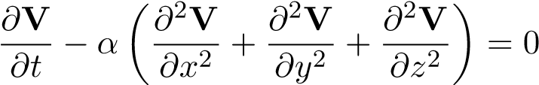 (1)
where x,y,z are the space dimensions and α is a parameter. If you felt inclined, you could define
V as
V = y²z − cos(0.1x)
1
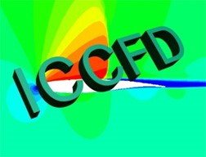
Figure 1: This is the logo of ICCFD.
for a non-exact solution. Computational fluid dynamics can be used to discretize the equations, apply boundary conditions and simulation the unsteady nature of the flow. An innovative method to simulate the heat equation could even be submitted to ICCFD11.
The scope of ICCFD11 is devoted to all innovative aspects of CFD, basic and applied. Subjects of interest include but are not limited to:
- Innovative algorithm development for flow simulations: higher-order methods, iterative methods, parallel algorithms, mesh adaptation, grid generation, meshless methods, immersed boundary methods and level-set methods.
- Advances in modeling of flow physics in the area of: steady and unsteady flows, compressible and incompressible flows, flows in porous media, hypersonic and reacting flows, turbulence (transition, DNS/LES, etc.), multi-phase flows, boundary layer stability and vortex dynamics.
- Advanced multidisciplinary applications using the above mentioned technologies: aeroacoustics, flow control, biomedical fluid mechanics, large scale applications, verification and validation methods, and turbomachinery.

Conclusion and Future Work
ICCFD11 will be held at the beautiful Royal Lahaina Resort. Situated near the world-famous Kaanapali Beach on the west coast of Maui, the venue offers a gorgeous backdrop. We wholeheartedly invite you to attend and make reservations while reduced conference rates are available. Aloha.

References
- J. Doe. Important book title: A complete work. ACME. 2012.
- J. Doe and B. Schmit. Novel approach to innovation and synergy. Int. J. Sci. Tech., 54:695706, 2012.

