|  |  |
| --- | --- |
| **Tenth International Conference on**  **Computational Fluid Dynamics (ICCFD10),**  **Barcelona, Spain, July 9-13, 2018** | **ICCFD10-xxxx** |

Abstract Template of 10th International Conference on Computational Fluid Dynamics in Barcelona, Spain 2018

D. Reynolds*, C. Kelly* and F. Reynolds*,**

Corresponding author: d.reynolds@paddyspub.xyz

* Paddy’s Pub, USA

** Sunny Real Estate, USA.

**1 Introduction**

Please use this adapted version of the full paper to provide the **1-2 page** abstract, please include details of the problem and a brief summary of your findings.

**2 Main Body**

This document allows you to easily include references [1, 2], equations, figures (see Figure 1) or any- thing else you desire into a clean and compact environment of LATEX. For example if you’d like to impress a date you can write the unsteady heat equation as



where *x,y,z* are the space dimensions and α is a parameter. If you felt inclined you could define V as



for a non-exact solution. Computational fluid dynamics can be used to discretize the equations, apply boundary conditions and simulation the unsteady nature of the flow. An innovative method to simulate the heat equation could even be submitted to ICCFD7.

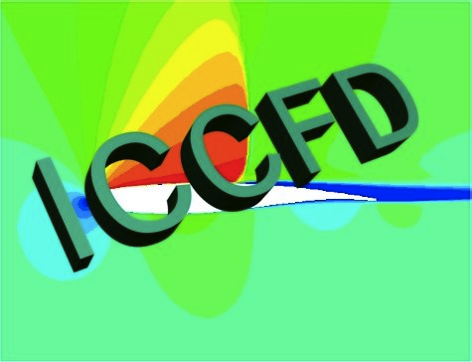

Figure 1: This is the logo of ICCFD.

**2.1 Subsection Title Example**

**2.1.1 Sub-subsection Title Example**

**References**

1. J. Doe. *Important book title: A complete work*. ACME. 2012.
2. J. J. Doe and B. Schmit. Novel approach to innovation and synergy. Int. J. Sci. Tech., 54:695-706, 2012.